**EXCELL ASSIGNMENT – 18**

**QUESTION -1.** **What are comments and what is the importance if commenting in any code?**

**ANSWER-**

In the context of Excel, comments (or cell comments) are annotations that can be added to individual cells to provide additional information or context. They are not lines of code as in traditional programming languages, but they serve a similar purpose in enhancing understanding and documentation. In Excel, you can attach comments to specific cells, and when you hover over a cell with a comment, the comment text is displayed.

The importance of commenting in Excel includes:

1. Explanation of Data: Comments can be used to explain the content of a particular cell, especially when the data is not self-explanatory. This is helpful for other users who may be reviewing or working with the spreadsheet.
2. Documentation: If your Excel spreadsheet contains complex formulas, calculations, or macros, comments can serve as a form of documentation. They help explain the logic behind certain decisions or calculations, making it easier for others to understand and maintain the spreadsheet.
3. Collaboration: When multiple people are working on a spreadsheet, comments can facilitate communication. Team members can use comments to discuss specific cells, share insights, or provide instructions for others.
4. Auditing and Validation: Comments can be used to indicate why certain values are entered or to provide information about the source of the data. This is valuable when auditing the spreadsheet or validating its accuracy.
5. Educational Purpose: For those who are not familiar with the spreadsheet, comments can act as a guide or educational resource. They can provide tips on how to use the spreadsheet effectively or explain the purpose of specific cells.

To add a comment to a cell in Excel:

1. Right-click on the cell where you want to add the comment.
2. Choose "Insert Comment" from the context menu.
3. Enter your comment in the comment box that appears.

While comments in Excel are not equivalent to traditional code comments, they serve a similar purpose in terms of providing clarity, context, and documentation. Using comments

judiciously can make your Excel spreadsheets more understandable and maintainable, especially when shared with others.

**QUESTION 2. What is Call Statement and when do you use this statement?**

**ANSWER-**

It seems there might be a bit of confusion in your question. In traditional programming languages, a "Call Statement" is used to invoke a subroutine or function. However, in the context of Excel, there isn't a direct "Call Statement" as you would find in programming languages.

In Excel, you typically use formulas and functions to perform calculations and manipulate data. Formulas are entered directly into cells or used in functions. For example, you might use a formula like =SUM(A1:A10) to sum the values in cells A1 through A10.

If you're referring to "calling" a macro or a subroutine in VBA (Visual Basic for Applications), then you might use the Call keyword, but it's optional.

Here's an example:

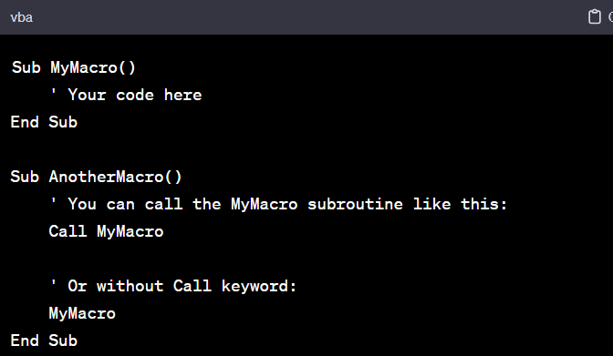

In the VBA environment within Excel, the **Call** keyword is optional, and you can simply use the subroutine or function name followed by parentheses.

If your question is related to something else or if you have a specific scenario in mind, please provide more details so that I can offer a more accurate and helpful response.

**QUESTION 3. How do you compile a code in VBA? What are some of the problem that you might face when you don’t compile a code?**

**ANSWER-**

In VBA (Visual Basic for Applications), code compilation is not a separate step as it is in some other programming languages. VBA code is typically interpreted and executed directly within the host application, such as Microsoft Excel. However, there is a process called "compilation" that occurs at runtime when the VBA code is executed.

When you run or trigger a macro in Excel (which is written in VBA), the code is compiled and then executed. During this compilation process, the VBA compiler checks the syntax of your code and ensures that it adheres to the rules of the VBA language. If there are any syntax errors, the compiler will identify them, and you'll see an error message. This process helps catch errors before the code is executed.

To manually force a compilation check in the VBA editor:

1. Open the VBA editor by pressing Alt + F11 in Excel.
2. In the VBA editor, go to "Debug" in the menu.
3. Choose "Compile VBAProject" from the dropdown.

This will trigger the VBA compiler to check the syntax of your code without actually running it.

Some common problems that you might face if you don't compile your code:

1. Syntax Errors: If there are syntax errors in your code, they won't be caught until you try to run the code. Compiling the code beforehand helps identify these errors early on.
2. Undeclared Variables: If you have used variables that haven't been declared, the compiler can catch this during the compilation process. If not declared, these variables might lead to runtime errors when the code is executed.
3. Misspelled Function or Subroutine Names: Compilation helps catch misspelled function or subroutine names, preventing runtime errors that might occur when trying to call non-existent procedures.
4. Incorrect Argument Types: If you pass arguments to a function or subroutine of the wrong type, the compiler can catch these errors during compilation.
5. Missing References: If your code relies on external libraries or references, compilation can help identify missing or broken references.

In summary, while VBA doesn't have a separate compilation step as in some other languages, the compilation process occurs automatically at runtime when you run your code. Manually triggering a compilation check in the VBA editor is a good practice to catch and fix errors before execution, improving the reliability and efficiency of your VBA macros.

**QUESTION 4. What are hot keys in VBA? How can you create your own hot keys?**

Top of Form

ANSWER-

In VBA (Visual Basic for Applications), hotkeys are keyboard shortcuts that can be assigned to specific actions or procedures in the VBA editor or within your VBA code. Hotkeys make it easier to perform common tasks quickly. While the VBA editor itself has its set of default hotkeys, you can create custom hotkeys for your own procedures or actions within your code.

Here's how you can create your own hotkeys for procedures in VBA:

**Assigning Hotkeys to Procedures in VBA Editor:**

1. **Open the VBA Editor:**
   * Press **Alt + F11** in Excel or another Microsoft Office application to open the VBA editor.
2. **Navigate to the Code Module:**
   * Go to the module where your VBA code is located.
3. **Select the Procedure:**
   * Click inside the procedure to which you want to assign a hotkey.
4. **Assign the Hotkey:**
   * In the VBA editor, right-click on the procedure name.
   * Choose "Options" from the context menu.
   * In the "Procedure Attributes" window, you'll find an option called "Shortcut key." Enter the desired letter (or number) as the hotkey.
   * Click "OK" to save.

**Using Hotkeys within Your VBA Code:**

If you want to create hotkeys that trigger specific actions within your code, you can use the **Application.OnKey** method. This method allows you to define a key combination that will trigger a specific procedure.

Here's an example:

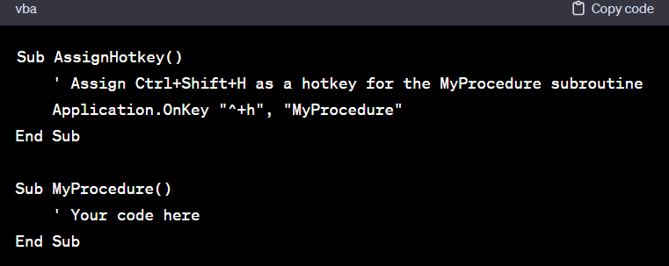

In this example, **^+h** represents the hotkey Ctrl+Shift+H. When you run the **AssignHotkey** procedure, pressing Ctrl+Shift+H will then execute the **MyProcedure** subroutine.

Remember to handle hotkeys carefully, as they can override default application shortcuts, and it's essential to choose combinations that are not already reserved by the application.

After using custom hotkeys, it's a good idea to document them in your code or project documentation for future reference and collaboration with other developers.

**QUESTION 5. Create a macro and shortcut key to find the square root of the following numbers 665, 89, 72, 86, 48, 32, 569, 7521**

**ANSWER-**

**Step-1**

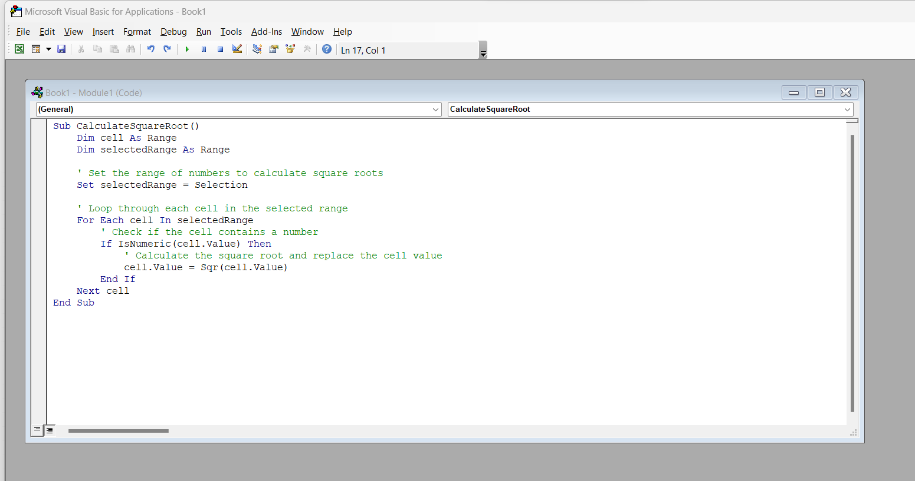

Step-2 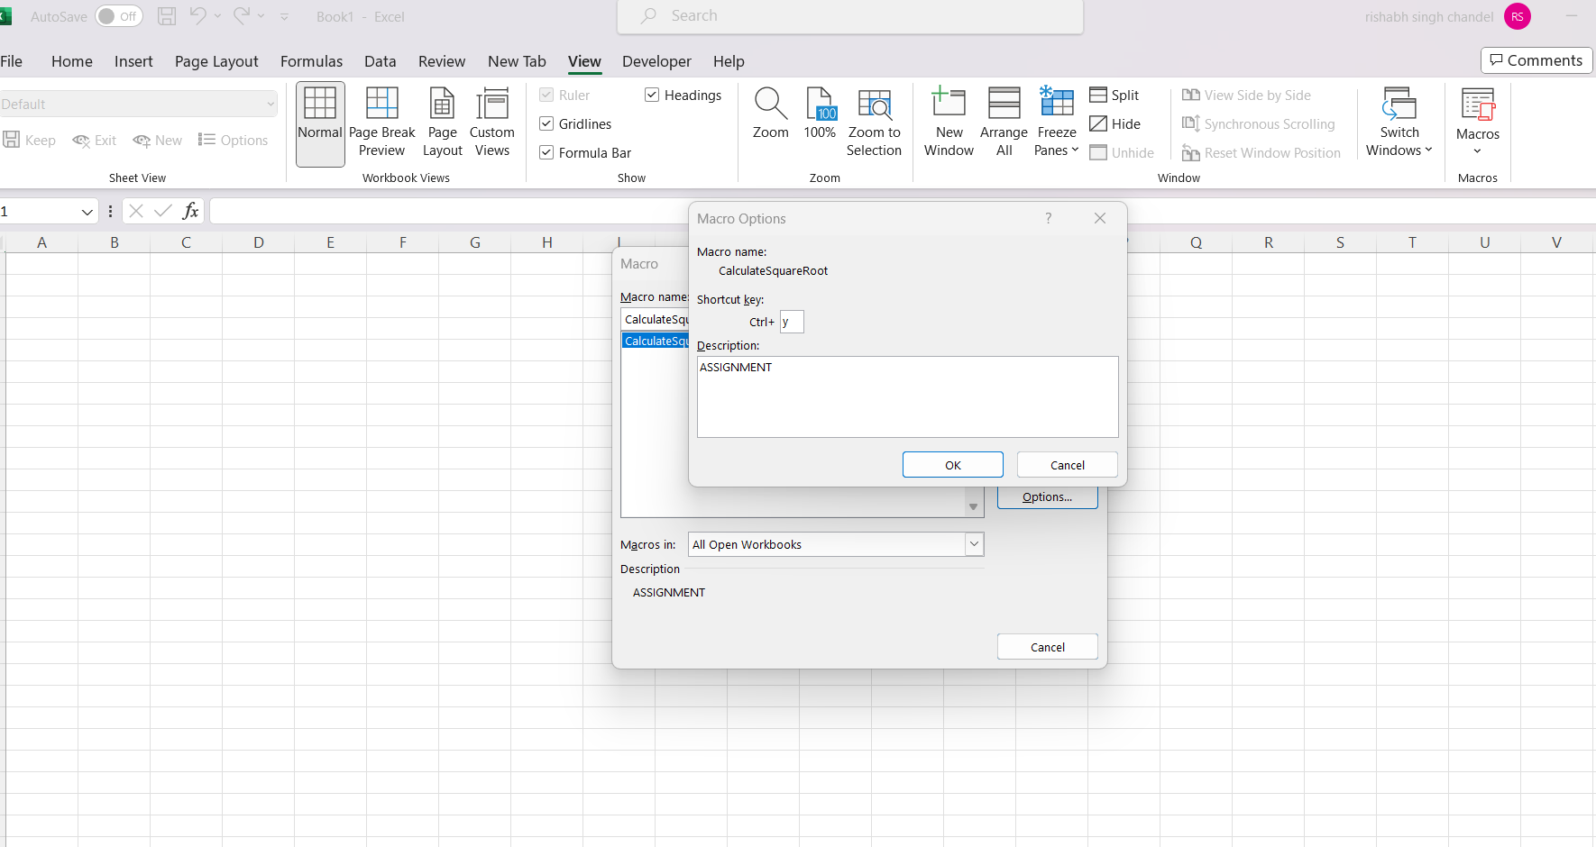

Step-3

Select range and press short key(CTRL+Y) that I have created

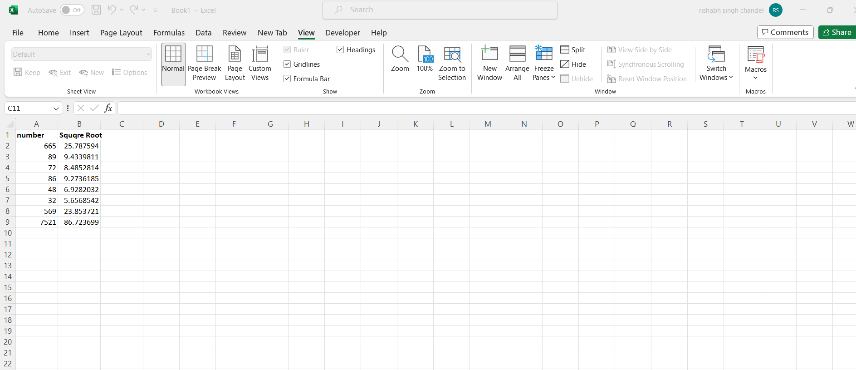

QUESTION -6 **. What are the shortcut keys used to**

**a. Run the code**

**b. Step into the code**

**c. Step out of code**

**d. Reset the code**

**ANSWER-**

**a. Run the code : ANSWER=** F5

**b. Step into the code: ANSWER=** F8

**c. Step out of code : ANSWER =** Shift + F8

**d. Reset the code: ANSWER=** Ctrl + Break